Caroline Marolda
Professor Gordon
ENGL 3180
28 April 2020
Handwritten Letters as an Influence on Social Media
Introduction
As technology continues to evolve, so do the ways that we communicate with each other. Because different technologies are centered around previous ones, there are various features on different social media platforms that are based on the personalization of handwritten letters and other older ways of communicating with others; these features make social media platforms more personal to their users. Social media platforms such as Facebook and Instagram allow users to make content and discourse more personal through direct messages, personalized profiles, and story posts.
Assessing Handwritten Letters and Digital Discourse
Written letters can be understood as a social media platform of the past. Handwritten letters are considered to be very personalized due to handwriting varying per person and the differing relationships between various interlocutors. As Richard Kern notes in his chapter “The Individual and Design,” “typed and printed utterances, with their uniformity of typefaces, are comparatively impersonal, perhaps even duplicitous” (Kern 112). By eliminating the individuality found in handwriting and reducing it to monotonous characters in a given font style, digital discourse becomes overall less personalized. However, something that is omitted in Kern’s chapter is that social media platforms continuously find ways to make digital discourse less impersonal through their different features. Even though online conversations will always be mediated by smart phones and the application being utilized, social media platforms increasingly evolve to eliminate the feeling of mediation by adding features that users can personalize.
Everything comes from something, and in his chapter “The Death of the Author,” Roland Barthes states, “texts are made of multiple writings and drawn from many cultures” (Barthes 148). Social media platforms gained inspiration from older forms of communication, such as handwritten letters being an inspiration for direct messages, to make their respective platform less impersonal. Similar to texts, different social media platforms have taken inspiration from each other to include more ways to communicate within a single platform. One example of this concept is how Instagram implemented their Stories feature, which is very similar to Snapchat because of the optional filters and how the post stays visible for only 24 hours. Their different features make discourse between interlocutors more personal and personalized.
Making Discourse via Social Media More Personal – Direct Messages
One way that social media platforms allow users to have a more personalized experience is through direct messages. Direct messages are a form of one-one-one communication—similar to letters—but they can also include groups of participants. Interlocutors who utilize the direct message feature on social media platforms such as Instagram and Facebook can strengthen their relationships, which is a similar impact that handwritten letters can have on its participants. When thinking about the switch from handwritten letters to digital discourse, it is important to note that the content of the messages in question can stay the same; the medium is the primary difference between the two.

Figure 1 - Handwritten Letter
In his chapter “Social Ecologies,” Kern states that “the practices that people establish in these environments are fundamentally social, not technological” (Kern 98). Social media platforms allow their users to virtually connect with those included in their friend groups, or the people who follow their account. The transmission of conversations between these people is similar to letters due to the content that letters can contain, but their digital discourse can be embellished with various elements such as gifs and memes. Although the way that the message is delivered differs between handwritten letters and digital discourse, the latter still offers ways to be personalized.
Making Discourse via Social Media More Personal – Profiles
Profiles play a large role in making social media less impersonal. Social media users can help convey their identities online by customizing the appearance of their profile. According to the study “Online First Impressions: Person Perception in Social Media Profiles” that was conducted in 2016 by Chantal Bacev-Giles and Reeshma Haji, nearly 70 percent of adults in the United States had accounts on at least one social media platform (Bacev-Giles & Haji 50). The same study found that Facebook had approximately 1.09 million active users each day, which means that a large number of users can view a particular profile each day. Kern says that “the stated purpose of Facebook is to keep up with friends, to share photos, links, and videos with them, and to learn more about the people one meets” (Kern 85). Because of this, it is important for users to inform the people who view their profile about who they are. Doing so will not only refresh interlocutors of their conversation counterparts, but it will also give potential followers more information on who a specific user is.
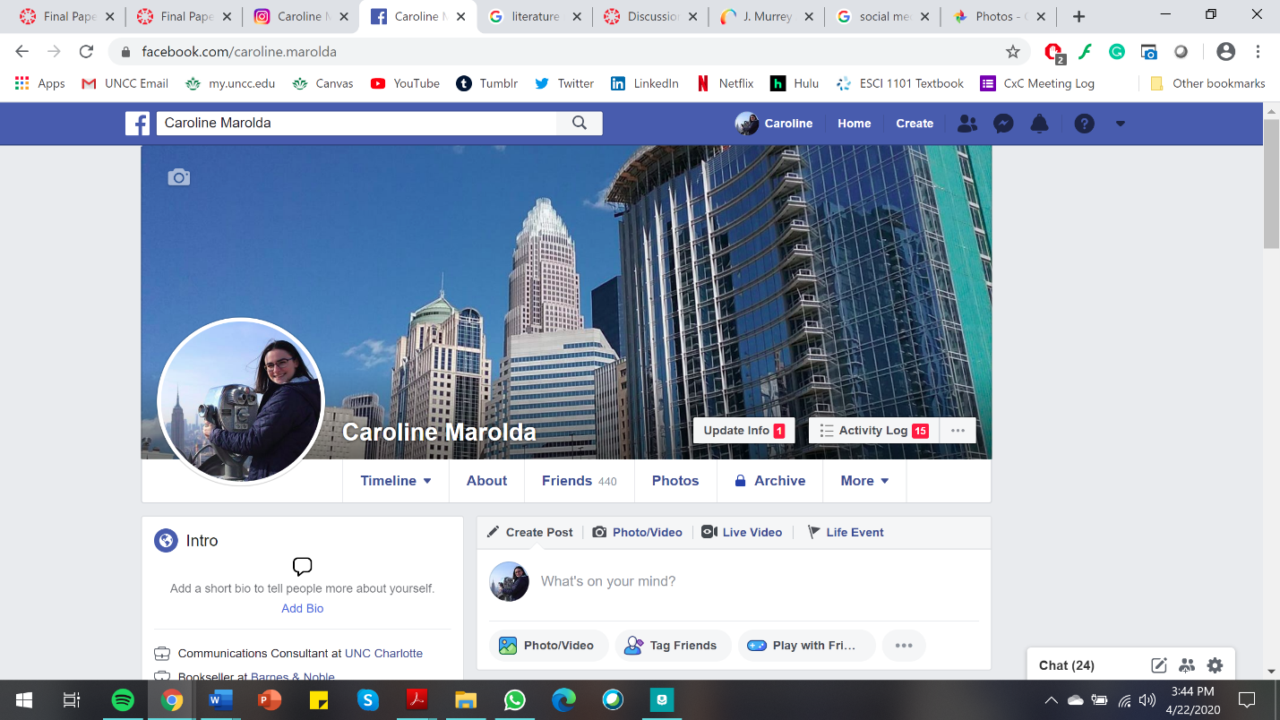
Figure 2 - Facebook Profile
As captured in Figure 2, Facebook allows users to customize their profile in several areas, such as their profile picture, banner image, and a bio within the “Intro” section of the page. Taking a look at another platform, Instagram also grants users a dedicated space on their profiles for a short bio to give their followers, as well as prospective followers, more information about themselves. Some users may use all of the allotted characters while others choose to keep theirs short and sweet. All of these features allow users to have a way to essentially market themselves towards others.
Perceived similarity is one major determinant for whether or not a person will like someone they recently met. People are attracted to those they perceive are similar to themselves and similar to their ideals, and this is also a strong determinant of liking for online friendships. Supporting the idea that “less is more”, online profiles are perceived as more likeable when less information is presented and profiles are more ambiguous (Bacev-Giles & Haji 52).
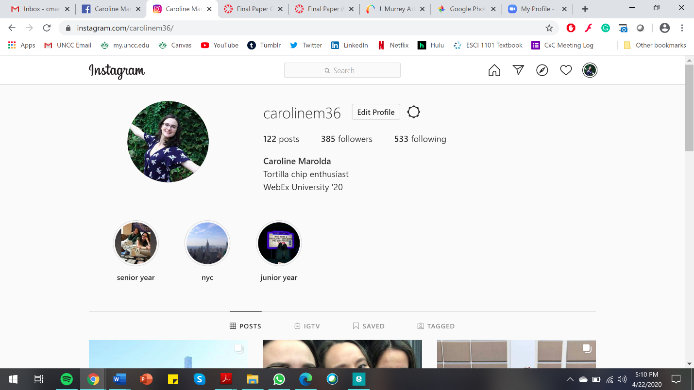
Figure 3 - Instagram Profile
With a profile picture, a banner image, and a bio being the main components of a profile—although not all platforms will have all three, as demonstrated by comparing and contrasting Figures 2 and 3—users are given several opportunities to make themselves be perceived as likeable to others through personalizing their profile. As demonstrated through Bacev-Giles & Haji’s study, social media users gravitate towards those they find similar to themselves, meaning that how one’s profile is perceived will act as a first impression. Regardless of how one chooses to personalize the different features on modern-day social media platforms like Facebook and Instagram, it is important to notice the personal features found in previous channels of communicating. As far as handwritten letters go with demonstrating aspects of social media platforms, profiles were not prevalent; instead, an equivalent would be the name listed for the return address and the name that follows “sincerely” or other complimentary closings.
Making Discourse via Social Media More Personal – Instagram Stories
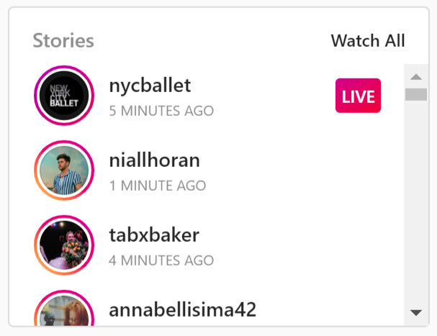
Figure 4 - Instagram Story Posts
Another area where social media allows users to make their discourse more personal is through Instagram’s Stories feature. Instagram Stories “enables you to share multiple photos and videos, and they appear together in a ‘slideshow format’” (Pocket-Lint) rather than being shared in a dedicated profile post that would also appear in the feeds of one’s followers. However, anything posted on a user’s Stories will disappear from their profile after 24 hours. When a user posts to their Instagram Stories, they are essentially giving their followers quick updates about their day in the format of pictures, videos, or texts. Figure 4 shows a list of Instagram users who have added content to their Stories within the 24 hours that the screenshot was captured.
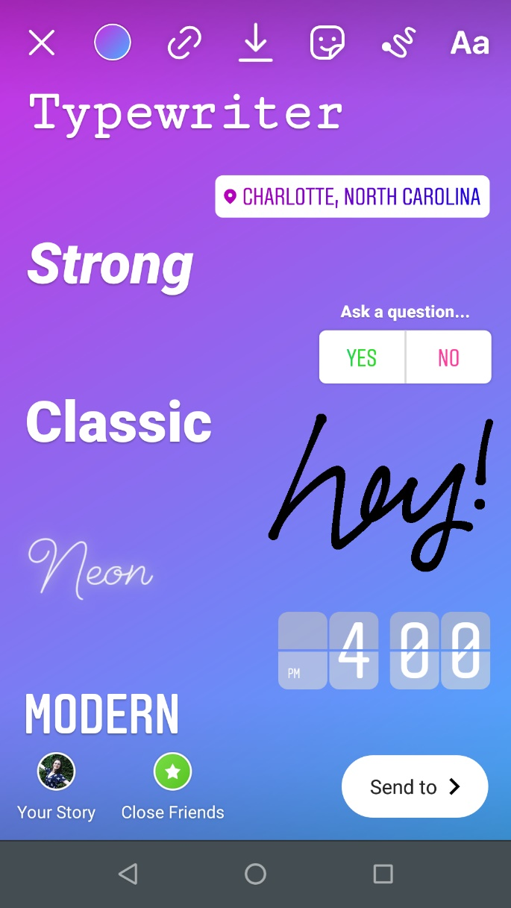
Figure 5 - Instagram Story Options
Instagram gives many options to its users in terms of personalizing their Stories; this includes a number of fonts, the option to add stickers, have viewers submit responses, and being able to draw pictures with the doodle tool. As demonstrated above in Figure 5, the doodle tool has been utilized as a way to act as a handwriting equivalent to write the message “hey!” on the post. Posts can also be customized this way but be sent to a single person, to a group of followers, or it can be posted on their “Friends Only” story in which a selected group of followers are only able to view the Stories. These options allow users more ways to make their posts content more personalized towards a specific person, which is a quality found in handwritten letters. This feature is reminiscent of handwritten letters because when composing a letter, the writer can choose the color of their pen and choose to include images within the letter’s envelope to provide and showcase visuals of what the letter may be describing.
Counter-Argument
With a new major change in communication comes hesitation towards conforming to the new channel of communication, such as transitioning from primarily communicating via handwritten letters to participating in digital discourse through social media platforms. One example of apprehension centered on transitioning to a new type of technology is when Gutenberg’s printing press was invented and transformed book printing. Kern’s chapter “Paper and Print” elaborates on how there was resistance towards the printing press reproducing books at an unprecedented rate. There were many reasons that were “partly religious, partly economic, and partly technical. With regard to religion, only the handwritten word was considered sacred” (Kern 152), and this preference of a handwritten text can be compared to the preference of composing a letter by putting pen to paper. Kern goes on to further elaborate that the proper social ecology must be present in order for a technology, such as Gutenberg’s printing press, to thrive and become a successful influence on society (Kern 153). The present-day fast paced American society calls for quick channels of communication, which is something that is not easily achieved by handwritten letters because they are not nearly as practical as digital discourse in the context of the United States. It is important to keep up with technological advantages that society becomes reliant on. Quick communication through technology, such as social media applications, fits the bill for today’s day and age, whereas handwritten letters were more suited for a time where digital technology was not as prevalent or relied upon.
As previously mentioned, a letter written on paper has its differences from a message sent via a digital technology, but neither format is omitted from being mediated in a way that impacts how a message is perceived by the recipient. Kern’s chapter, “Material Resources: Why the Medium Matters,” compares and contrasts the print version of the New York Times with the newspaper’s website. By doing so, Kern found that regardless of how the images were the same in each medium, he was able to interact with them differently depending on whether he was viewing the print or digital edition of the images (Kern 59).
Electronic and print mediums each have their distinctive advantages, but they are different. Electronic text does not supplant print text – the two coexist and are complementary. Readers adapt their reading style to the medium, and they choose a medium according to their purpose, preference, and situation (Kern 61).
While a handwritten letter can be more personal than social media platforms in terms of its physical form, the electronic content is still engaging for its recipient—an important note on the side of utilizing the digital technology that is readily available in our modern-day American society. In the chapter “Writing Redesigned: Electronically Mediated Discourse,” Kern states that “research has shown on aggregate that online communication is no less emotional or engaging than face-to-face communication, and if anything, it involves more explicit and frequent expression of emotion,” (Kern 177-178) demonstrating that communication completed through different modes or channels can create equally large impacts and have similar—if not stronger—benefits. The channel of communication is up to the interlocutors, but it is important not to rule out a specific channel, such as social media platforms, due to the belief that the platform will not be as impactful as a more traditional channel, such as utilizing handwritten letters.
Conclusion
Although technology and social media platforms are constantly evolving and shifting, it is important to recognize that these changes are influenced by previous technological advantages and ways of communicating. Technology continuously adapts to fit the needs of different social ecologies and social media encourages users to connect in a way that can be both compared and contrasted from earlier communication channels like handwritten letters. Social media platforms will continue to advance and evolve to make virtual conversations feel less mediated by technology, allowing for them to have increased levels of usability in order to feel more personal rather than impersonal.

Works Cited
Bacev-Giles, Chantal, and Reeshma Haji. “Online First Impressions: Person Perception in Social Media Profiles.” Computers in Human Behavior, vol. 75, Elsevier Ltd, Oct. 2017, pp. 50–57, doi:10.1016/j.chb.2017.04.056.
“The Death of the Author.” Image, Music, Text, by Roland Barthes, Fontana, 1977, pp. 142–148.
“The Individual and Design.” Language, Literacy, and Technology, by Richard Kern, Cambridge University Press, 2015, pp. 99–132.
Le Grove, Suzie. “Beautiful Stationary.” The English Home, www.theenglishhome.co.uk/beautiful-stationery-fit-for-handwritten-letters/.
Marolda, Caroline. “Screenshot of a Facebook Profile.” Facebook, 2020.
Marolda, Caroline. “Screenshot of an Instagram Profile.” Instagram, 2020.
Marolda, Caroline. “Screenshot of Instagram Story Posts.” Instagram, 2020.
Marolda, Caroline. “Screenshot of Instagram Story Options.” Instagram, 2020.
“Material Resources: Why the Medium Matters.” Language, Literacy, and Technology, by Richard Kern, Cambridge University Press, 2015, pp. 53–78.
“Paper and Print.” Language, Literacy, and Technology, by Richard Kern, Cambridge University Press, 2015, pp. 150–167.
“Social Ecologies,” Language, Literacy, and Technology, by Richard Kern, Cambridge University Press, 2015, pp. 79–98.
Tillman, Maggie. “What Are Instagram Stories and How Do They Work?” Pocket-Lint, 29 June 2018, www.pocket-lint.com/apps/news/instagram/138416-what-is-instagram-stories-and-how-does-it-work.
“Writing Redesigned: Electronically Mediated Discourse.” Language, Literacy, and Technology, by Richard Kern, Cambridge University Press, 2015, pp. 168–192.

